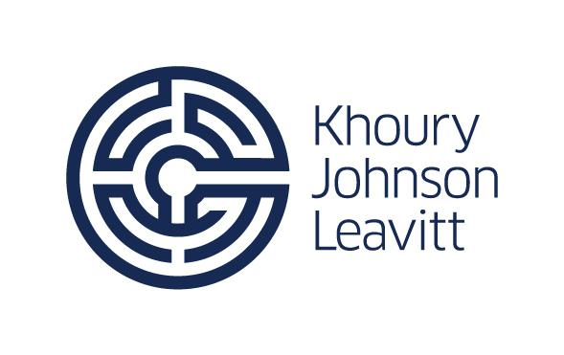
KJL Client Update 4.17.20

The Khoury Johnson and Leavitt team remain informed and engaged during these times of uncertainty. We are in communication with leadership in the executive, legislative and judiciary branches of state government, in addition to locals on a regular basis. Updates will continue every Friday as a mechanism to recap relevant activity from the past week.

SENATOR STAMAS CALL NEXT WEEK
We are pleased to share that we will host a call with Senator Stamas, Appropriations Committee Chair, on April 22 at 10am. We will format the call with a moderator and allow clients to submit questions in advance. If you are interested in participating, please contact Lauren Bunn at lauren@kjlteam.com.

MI FISCAL AGENCY MARCH 2020 REPORT
The Michigan Senate Fiscal Agency published their March 2020 report overviewing a Michigan revenue update as well as collections on major state taxes. The report reviews Executive Orders issued in response to COVID-19, suggesting these reflected little economic impact on most revenue received in March. They assume revenue impacts resulting from the COVID-19 pandemic will not be apparent until April 2020. However, sales tax collections from auto sales are down 18.5% from last year which could be a direct impact of COVID-19. Other revenue sources likely to reflect impacts from COVID-19 include gas tax collections (down 22.6%), diesel tax collections (down 21.6%), and casino tax collections (down 59%).

March 2020 tax collections were $80.8 million below the estimated totals. Additionally, Net Income tax revenue was down 12% from last year. Lower than expected Net Income tax revenue mostly reflects individual income tax refunds, which exceeded estimated totals by $56.1 million. These refunds reflect activity from the previous tax year and exceed estimates because the Department of Treasury processed the most returns in history through March. Year-to-date sales tax collections are up 5.4% from last year ($11.2 million above estimated totals). Lottery Revenue to the School Aid Fund is down 31.5%, this decline reflects large Powerball and MegaMillions Jackpots in March 2019 - which pushed the monthly lottery collections to the highest total in the history of the Lottery. March 2020 Lottery revenue nearly equaled the March average over the last ten year. To see the full report, click here.
- Executive Order 48 extends virtual meeting option under OMA to May 12 (4/14)
- FAQ page on Executive Order 42 – “Stay at Home” (4/13)
- ED 2020-03 - Restrictions on State Discretionary Spending During the COVID-19 Emergency
- Midwest Governors Announce Partnership to Reopen Regional Economy
- www.misenategop.com/OpenMISafely/
KJL COVID RESOURCE TAB
A COVID 19 resource tab has been added to our website www.kjlteam.com. We will continue to update that tab with information relevant to our clients. Also, if you haven’t already, please follow us on Facebook and Instagram for daily information.

ADDITIONAL RESOURCES
www.michigan.gov/coronavirus.com
www.michigan.gov/ag
www.cdc.gov/coronavirus.com
www.congress.gov.com
www.michiganbusiness.org

KJL TEAM CONTACT INFORMATION
Ron Khoury – ron@kjlteam.com, (517) 881-6356
Stephanie Johnson – stephanie@kjlteam.com, (517) 648-1602
Andy Leavitt – andy@kjlteam.com, (810) 625-0861
Marcy Lay – marcy@kjlteam.com, (517) 282-3295
Ryan Burtka – ryan@kjlteam.com , (313) 605-3878
Karen Currie – karen@kjlteam.com, (616) 706-2282
Mike Zimmer – mike@kjlteam.com, (517) 285-4126
Brian Clark – brian@kjlteam.com, (517) 410-3430
Lauren Bunn – lauren@kjlteam.com, (616) 826-1262

